Title should be written in non-capital letters/sentence case using
Lato, size 14, style: Title (maximum 15 words)
Author ¹⁾, Author ²⁾, Author ³⁾ etc.
¹⁾ Name of Affiliation
^{2), 3)} Name of Affiliation
Corresponding author, e-mail: author@email.com
ABSTRACT [Lato, 10, style: Abstract], single-spaced, maximum 300 words
Put your abstract here. Briefly explain your research purpose, background, methodology used, findings and conclusion.
KEYWORDS [Lato, 10, style: Abstract], single-spaced, maximum 5 keywords
Keyword 1, keyword 2, keyword 3, keyword 4, keyword 5

general guideline:
Authors should follow the format presented for any submission of extended abstracts and full paper to ICPRIME. The extended abstract should be at maximum only 4 pages and submitted in Word document format.
The use of an incorrect format may result in your extended abstract being rejected. After submission, our editors and technical committee will check the extended abstract for plagiarism and suitability for acceptance.

INTRODUCTION [Lato, 12, style: Heading 1], single-spaced.
The Introduction should address: (1) background, (2) a brief literature review of related research, (3) reasons for conducting this research, and (4) questions about the objectives or research question. The sophistication, gap analysis, and novelty should be evident here. [Lato, 11, style: Normal], single-spaced.

METHODOLOGY [Lato, 12, normal], single-spaced.
This section outlines the research design and methods, including data collection techniques, sampling procedures, and tools used. It explains the rationale for these choices, how they align with the research objectives, and procedures for ensuring reliability and validity. Additionally, it describes the data analysis process, providing a clear account of how the research was conducted to enable replication and understanding of the findings. [Lato, 11, style: Normal], single-spaced.

Sub-heading [Lato, 11, style: Heading 2], single-spaced.

Sub-heading [Lato, 11, style: Heading 2], single-spaced.

RESULTS & DISCUSSION [Lato, 12, normal], single-spaced.
This section includes the results of data analysis, hypothesis testing, answers to research questions, findings, and interpretation of the findings.
The use of tables, figures, and other materials should be strictly supportive and substantial, such as tables of statistical test results, figures of model test results, etc. The discussion of results should be argumentative, addressing the relevance between results, theory, previous research, and empirical facts found, as well as demonstrating the novelty of the findings. [Lato, 11, style: normal], single-spaced.
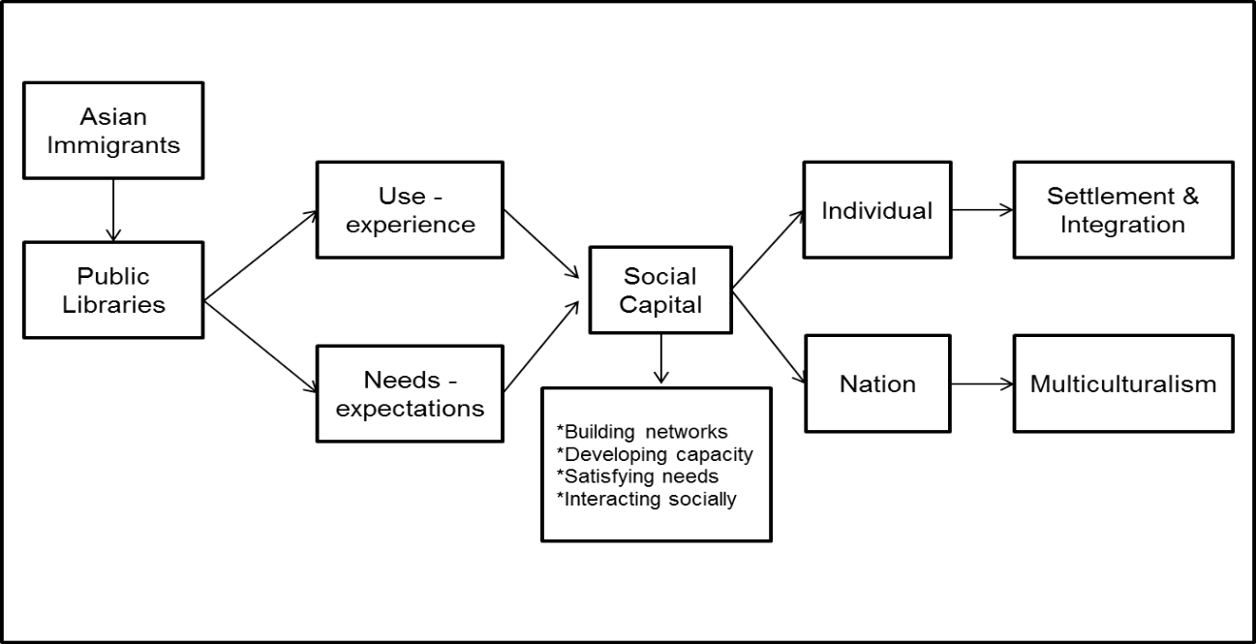
Figure 1. Model of Community Library Use by Immigrants [Lato, 10, Style: Figure/Table, Centered]
Source: (Last Name, Author) [Lato, 9, Style: Caption,Source, Centered]

Table 1. Reasons for visiting the library [Lato, 10, Style: Figure/Table, Align Left]
No | Reasons for visiting the library (10 pt) | Frequency  (n=139) | %
1 | Looking for sources of information | 88 | 63%
2 | Studying | 59 | 42%
3 | Meeting friends | 55 | 40%
Source: Primary data processed, 2022 [Lato, 9, Style: Caption,Source, Align Left]

CONCLUSION [Lato, 12, STYLE: HEADING 1], single-spaced.
Conclusion may not be repetitions of ideas presented previously. It should provide implications of research and wider conception of ideas/understanding resulting from research. [Lato, 11, Style: normal], single-spaced.

ACKNOWLEDGEMENT*
In the acknowledgment section, briefly recognize individuals who provided significant help but are not authors, such as assistance with data collection or analysis. Acknowledge institutional and financial support by naming relevant organizations, grants, or funding bodies. Ensure that those mentioned have consented to be acknowledged. Avoid personal dedications or statements that could imply bias. [Lato, 11, Style: normal], single-spaced.
*This is an optional section

REFERENCES [Lato, 12, normal], single-space
All in-text citations must be registered in the References. A reference management application/software must be used, such as Mendeley, EndNote, Zotero, or others, and refer to APA 7th Edition (American Psychological Association). [Lato, 11, Style: normal], single-spaced.

The following are some examples of the 7th edition of the APA reference style:

>Book chapters:
Aarnitaival, S. (2010). Becoming a citizen-becoming information-literate? Immigrants’ experiences of information literacy learning situations in Finland-Chapter 14. In A. Lloyd & S. Talja (Eds.), Practicing information literacy. Bringing theories of learning, practice and information literacy together (pp. 301-329). Center for Information Studies, Charles Sturt University.
Strauss, A., & Corbin, J. (1994). Grounded theory methodology. In N. K. Denzin & Y. S. Lincoln (Eds.), Handbook of qualitative research (pp. 273-285). Sage.
Yura, P. (2020). ‘Good or bad’: How people think of me is not important. In B. Rudy & H. Dion (Eds.), Mental health policy: Bringing theories of learning and information literacy in practice (pp. 368-389). University of Life Press.

>Books:
Aaker, D. A., Day, G. S., & Kumar, V. (2013). Marketing research (11th ed.). Wiley.

>Journal articles with no doi:
Khoir, S., Du, J. T., Davison, R. M., & Koronios, A. (2017). Contributing to social capital: An investigation of Asian immigrants' use of public library services. Library & Information Science Research, 39(1), 34-45.
Loudon, K., Buchanan, S., & Ruthven, I. (2016). The everyday life information seeking behaviors of first-time mothers. Journal of Documentation, 72(1), 24-46.

Yu, L. (2011). The divided views of the information and digital divides: A call for integrative theories of information inequality. Journal of Information Science, 37(6), 660-679.

>Journal articles with doi:
Khoir, S., Du, J. T., & Koronios, A. (2015). Linking everyday information behavior and Asian immigrant settlement processes: Towards a conceptual framework. Australian Academic & Research Libraries, 46(2), 86-100. https://doi.org/10.1080/00048623.2015.1024303

>Conference proceedings:
Khoir, S., Du, J. T., & Koronios, A. (2014). Study of Asian immigrants’ information behaviour in South Australia: Preliminary results. Proceeding iConference, March 4-7 2014, Berlin, Germany, pp. 682-689. https://www.ideals.illinois.edu/handle/2142/47274

>Internet Documents and Government Publication:
Mercer, P. (2012). Immigrants change Australia's cultural identity. Voice of America News. http://www.voanews.com/content/immigrants-change-australias-cutural-identity/1246298.html

State Library of South Australia. (n.d). Strategic plan 2014-2017. http://www.slsa.sa.gov.au/webdata/resources/files/State_Library_of_SA_Strategic_Plan_2014-2017_-_Low_Resolution.pdf

- For more than 1 author – in the in-text citation, we only write the name of the first author’s last name, immediately followed by et al.
Example:
(Garrett et al., 2020)
- Place (city) of publication is no longer included in the reference.
Example:
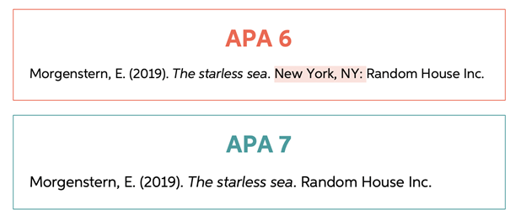
- DOI is written in complete format as follows: https://doi.org/xxxxx
Example:
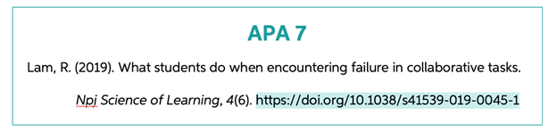
- No need to include the words "Accessed from" or "Retrieved from" before the URL.
Example:
Betts, J. (2020, July 18). APA format and citations. Bibliography.com: www.bibliography.com/apa/apa-format-and-citations

