The Title Should Reflect the Content of the Paper

Author¹, Author²* and Author¹

¹ Affiliation Faculty of Engineering, Universitas Indonesia, Depok 16424, Indonesia
² Affiliation Faculty of Engineering, Universitas ABC, Jakarta 10424, Indonesia
*Corresponding author e-mail: abcd@ui.ac.id

Abstract. Typed in italic and maximum length is 150 words. Full paper length is 5 (five) A4 pages. Technology of electronic waste treatment grows rapidly in the millennium era as the number of e-waste increases every year. On top of that, e-waste is composed of valuable metals that have promising economical potential. One of electronic waste processing technology are leaching- stripping method. In this research, electronic waste from PCB (printed circuit board) was leached using HCl 0.5 M and H₂O₂ 0.4 M solution with activated carbon addition. The experimental results were characterized using AAS (atomic absorption spectroscopy) and SEM (Scanning Electron Microscopy) - EDX (energy dispersive X-ray). Add a little bit of result and conclusion here.

Keywords: electronic waste, leaching, stripping, NaOH, HCl, H₂O₂, gold recovery

Introduction
The introduction should be succinct, with no subheadings. All text should use Times New Roman 11 fonts. Limited figures may be included only if they are truly introductory and contain no new results. For an extended abstract please describe at least one full page of A4 with significant results. The 8th International Engineering Students Conference (IESC) 2023 is an annual conference organized by Faculty of Engineering Universitas Indonesia, aims to provide a scientific and networking platform for young researchers and student in Engineering and Technology fields. The Conference will be held on 5-6 July 2023, in Depok, Indonesia.

Materials and Methods
The materials and methods section should contain sufficient detail so that all procedures can be repeated. It may be divided into headed subsections if several methods are described.

Results and Discussion

Subheadings
The results and discussion may be presented separately, or in one combined section, and may optionally be divided into headed subsections.

Advice on Equations
Equations should be provided in a text format, rather than as an image. Microsoft Word’s equation tool is acceptable. Equations should be numbered consecutively, in round brackets, on the right-hand side of the page. They should be referred to as Equation 1, etc. in the main text.

$x=\frac{-b±\sqrt{b^{2}-4ac}}{2a}$ (1)

Advice on Figures
At the point of submission, authors may provide all figures embedded within the manuscript at a convenient break near to where they are first referenced or, alternatively, they may be provided as separate files. All figures should be cited in the paper in a consecutive order. Where possible, figures should be displayed on a white background. When preparing figures, consider that they can occupy either a single column (half page width) or two columns (full page width), and should be sized accordingly. All figures must have an accompanying caption which includes a title and, preferably, a brief description (see Figure 1). If a figure consists of multiple panels, they should be ordered logically and labelled with lower case roman letters (i.e., a, b, c, etc.). If it is necessary to mark individual features within a panel, this may be done with lowercase Roman numerals, i, ii, iii, iv, etc. All labels should be explained in the caption. Panels should not be contained within boxes unless strictly necessary.

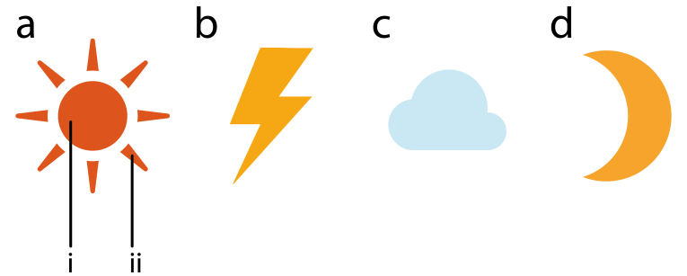
Figure 1: Representations of some common weather symbols. (a) The sun with (i) core, and (ii) rays. (b) Thunder bolt. (c) Cloud. (d) Moon.

The caption can also be used to explain any acronyms used in the figure, as well as providing information on scale bar sizes or other information that cannot be included in the figure itself. Plots that show error bars should include in the caption a description of how the error was calculated and the sample size (see Figure 2).

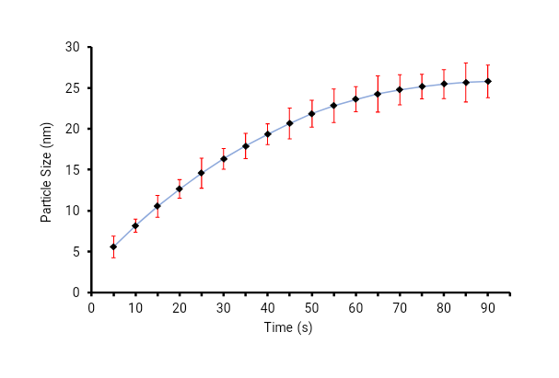
Figure 2: Plot of nanoparticle size with respect to time, recorded over a 90 s period. The error bars represent the standard deviation of measurements for 20 particles in five separate sample runs (n = 100).

Upon acceptance, authors will be asked to provide the figures as separate electronic files. At that stage, figures should be supplied in either vector art formats (Illustrator, EPS, WMF, FreeHand, CorelDraw, PowerPoint, Excel, etc.) or bitmap formats (Photoshop, TIFF, GIF, JPEG, etc.). Bitmap images should be of at least 300 dpi resolution, unless due to the limited resolution of a scientific instrument. If a bitmap image has labels, the image and labels should be embedded in separate layers.

Advice on Tables
Every table must have a descriptive title and, if numerical measurements are given, the units should be included in the column heading. Vertical rules should not be used (see Table 1). Tables should be cited consecutively in the text.

Table 1: Temperature and wildlife count in the three areas covered by the study.
Location | T [° C] | Turtles | Sharks | Octopuses | Starfish
Blue Lagoon | 21.2 | 5 | 3 | 4 | 543
Regent’s Canal | 5.2 | 8 | 0 | 24 | 312
Shark Bay | 12.8 | 4 | 7 | 9 | 122

Conclusions
The Conclusions section should clearly explain the main findings and implications of the work, highlighting its importance and relevance.

Funding Statement
Authors may state how the research and publication of their article was funded, by naming financially supporting bodies followed by any associated grant numbers in square brackets.

Acknowledgments
An Acknowledgements section is optional and may recognise those individuals who provided help during the research and preparation of the manuscript.

References
This paper template is extracted and modified from Hindawi Publishing. References will be reformatted in house, there is no need to adhere to a specific style at the point of submission. Authors are responsible for ensuring that the information in each reference is complete and accurate. All citations in the text must be numbered consecutively in square brackets, before any punctuation, for example, “as discussed by Smith [1],” and “as discussed elsewhere [2,3].” All uncited references will be automatically removed. The references should not contain footnotes. For your information, our citation style is:
[x] Author initials and surname, “Title in sentence style,” Journal title, vol. (volume number), no. (issue number), pp. (page numbers separated by an en-dash), Year.
For example:
[1] J. D. Watson and F. H. C. Crick, “A structure for deoxyribose nucleic acid,” Nature, vol. 171, no. 4356, pp. 737–738, 1953.
For articles with six or more authors, the first three authors are listed followed by ‘et al.’. When journals use only article numbers, no page numbers are necessary. For example:
[2] B. P. Abbott, R. Abbott, T. D. Abbott et al., “Observation of Gravitational Waves from a Binary Black Hole Merger,” Physical Review Letters, vol. 116, no. 6, Article ID 061102, 2016.

