HOW IS THE IMPLEMENTATION OF EMPLOYMENT RIGHTS OF PERSONS WITH DISABILITIES POKICY IN TEMANGGUNG REGENCY?

Dede Kurnaedi
Suranto Suranto

Universitas Muhammadiyah Yogyakarta,
Jl. Brawijaya, Bantul Daerah Istimewa Yogyakarta, Indonesia

Correspondence Email: kurnaedidede8@gmail.com

Submitted: ………., Reviewed:……….., Published: ………..

ABSTRACT
This study aims to determine the implementation of the policy of fulfilling the Labor Rights of Persons with Disabilities in Temanggung Regency with indicators of policy accuracy, implementation, targets, and the environment, as well as to determine the factors that influence it with indicators of communication, resources, dispositions, and bureaucratic structure. This research is in the form of a qualitative descriptive research using interviews, observation, and documentation as data sources and analyzed using data reduction, data presentation and drawing conclusions by collaborating with the Nvivo 12 Plus software. The results of the research show that the policy has been formulated according to the characteristics of the problem and has contained things that can solve the problem, carried out by the Personnel and Human Resource Development Agency in terms of Civil Servants management, as well as the Social Agency and the Industry and Labor Agency together with APINDO in terms of personnel. private work. However, the implementation is not optimal, because there are still problems, namely the lack of readiness of targets to enter the job market, lack of socialization, lack of human resources, budget, and equipment in disability service units. The factors that strengthen are communication to the implementer, well-executed authority resources, awareness and positive response from the implementer as well as leader support, implementation of SOPs and appropriate fragmentation.
Keywords: Policy Implementation, Persons with Disabilities, Employment Rights.

ABSTRAK (in Bahasa)
The journal contents of main problems or main of research, methods, and result or the analysis of research (max. 200 words). Set in Bahasa.

Keywords: (max. 6 words)

BACKGROUND
Human Rights based on the Law of the Republic of Indonesia Number 39 of 1999 concerning Human Rights, are a set of rights that are inherent in the nature and existence of humans as creatures of God Almighty and are His gifts that must be respected, upheld and protected by the state, law, Government, and everyone for the sake of honor and protection of human dignity and status. Protection and guarantee of rights are not only given to citizens who have physical and mental perfection (Shaleh, 2018), but also given to all citizens, including citizens with disabilities (Tan & Ramadhani, 2020).
Based on Law Number 8 of 2016 concerning Persons with Disabilities, Persons with Disabilities are any person who experiences physical, intellectual, mental and/or sensory limitations for a long time in interacting with the environment may experience obstacles and difficulties to participate fully and effectively with other citizens based on equal rights. Persons with disabilities are classified as one of the vulnerable groups (Ndaumanu, 2020), so that it requires special attention including its welfare.
One of the rights to welfare is the right to obtain a decent job (Tan & Ramadhani, 2020) In this case, persons with disabilities are still vulnerable to discrimination related to fulfilling their right to work (Lestari et al., 2017), especially the obstacle in terms of "physically and mentally healthy" which has always been one of the general requirements that absolutely everyone has (Tampubolon, 2019).
Temanggung Regency is the district where the Center for Rehabilitation of Intellectual Disabled Persons is placed, and based on data from the Central Statistics Agency in 2016, Figure 1. Describe temanggung Regency is the district with the third largest number of persons with disabilities in Central Java Province with the following number of persons with disabilities.
Figure 1. Persons with Disabilities in Temanggung Regency in 2021Source: Temanggung Regency Social Service

The total number of people with disabilities in Temanggung Regency is 5,668 people with the highest number being physically/disabled people with 1,608 people and the lowest being blind, deaf and speech impaired with 34 people. As for those aged 18-40 years, there were 1,437 people or 25.3% of the total. In addition, the Industry and Labor Agency also released data that out of a total of 27,769 workers, only 9 people were workers with disabilities or 0.03% of the total workforce in Temanggung Regency. This clearly shows that workers with disabilities are still very minimal when compared to non-disabled workers. This is odd considering that there is already Regional Regulation Number 7 of 2015 concerning Protection of the Rights of Persons with Disabilities which regulates this matter, but the employment rate for persons with disabilities is still low.
In previous research, Prasojo (2020) measured the level of work participation of persons with disabilities based on 4 indicators, namely, education, age, gender, and type of disability. Meanwhile Sadri & Muchtar (2021) focus on the obstacles to optimizing the provision of job opportunities whose scope is in Government Agencies. Meanwhile, Arzul et al., (2019) focuses on the role of regional apparatus in efforts and constraints to increase employment opportunities for persons with disabilities. Meanwhile, Tan & Ramadhani (2020), Nanda & Herawati, (2021), and Susiana & Wardah (2019) focus their research on challenges and/or obstacles in fulfilling the right to work of persons with disabilities. On the other hand, Widjaja et al., (2020) focuses on the factors causing the gap in employment opportunities for persons with disabilities. As well as Shaleh (2018), Istifarroh & Nugroho (2019), and Halim (2021) focus their research on a legal and statutory perspective. These studies focus on the categorization of employment of persons with disabilities, the government's role in recruiting disabled workers, the legal vacuum, the challenges of fulfilling the employment rights of persons with disabilities in the form of the views of companies and society, the competence of persons with disabilities, as well as opportunities and accessibility. Whereas in this study the authors seek to focus on the government's role as a leading policy sector in implementing collaborative management to fulfill and protect labor rights in Temanggung Regency.
Richard E. Matland (1995) in Purwanti et al., (2019) developed a model called the Ambiguity-Conflict Matrix Model which explains that administrative implementation is implementation that is carried out in the daily operations of government bureaucracy, political implementation is implementation that needs to be politically imposed, because although the ambiguity is low, the level of conflict is high. Experimental implementation was carried out on ambiguous policies, but the level of conflict was low. In principle, the Matland matrix has "four precises" that need to be met in terms of policy implementation (Sholeh et al., 2021), namely 1) Policy Accuracy, in the form of a Policy containing things that can solve problems, Policy Formulation according to the character of the problem and suitability of policy makers; 2) Execution Accuracy; 3) Target accuracy; 4) Environmental Accuracy, namely the internal environment and the external environment of the policy.
Besides that, according to George Edward III (1980) in Tuti (2020) there are 4 factors that influence the success or failure of policy implementation, including factor 1). Communication consisting of the Transmission Dimension, Clarity Dimension, and Consistency Dimension. 2) Resources, which consist of human resources, budgetary resources, equipment resources and authority resources. 3) Disposition consisting of the implementer's awareness, the implementer's instructions/directions to respond to the program towards acceptance or rejection, and leader support. 4) Bureaucratic Structure in the form of SOP and fragmentation.
This study aims to determine the Implementation of Regional Regulation of Temanggung Regency Number 7 of 2015 concerning Protection of the Rights of Persons with Disabilities in the context of Fulfilling Employment Rights of Persons with Disabilities in Temanggung Regency, as well as to find out what factors influence the implementation of these Regional Regulations. The benefits of this research are theoretical benefits, which are expected to contribute to the development of governance knowledge in the form of results of studies on the implementation of local government policies, while practical benefits, in the form of donations to the Temanggung Regency government in implementing policies to fulfill labor rights for marginalized people, namely persons with disabilities.

METHOD
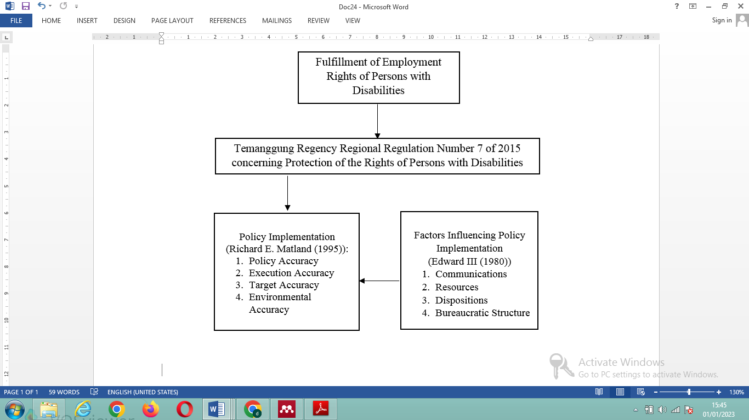
In this study, researchers used a qualitative descriptive research method. Qualitative descriptive is a research method that moves to a simple qualitative approach with an inductive flow, meaning that qualitative descriptive research begins with an explanatory process or event which can finally be drawn a generalization which is a conclusion from the process or event (Yuliani, 2018). The data comes from primary data, namely the results of interviews and observations, as well as secondary data in the form of reference sources such as journal publications, online news, legal products, and documents from regional apparatuses and business entities related to research.
Source: Processed by Researchers

Figure 1. Persons with Disabilities in Temanggung Regency in 2021Source: Temanggung Regency Social Service

As for analyzing the data in this study, the authors used data analysis techniques from Miles & Huberman which were collaborated using the Nvivo 12 Plus software. Miles & Huberman's theory in Fadli (2021) states that there are three types of activities in data analysis, namely data reduction, data presentation, and drawing conclusions. In this case Nvivo is used in the data reduction stage, namely the raw data collected is simplified using the Nvivo 12 Plus software by being analyzed and classified in stages through data coding. After the data coding process, a Crosstab Query is then carried out, namely in the form of identifying research factors that influence the research focus. The Nvivo 12 Plus software is used, because NVivo 12 Plus can translate text data, documents, news, and data series as well as social media (Brandão, 2015). The research was conducted by operationalizing the concept as follows in figure 2.

RESULT AND DISCUSSION
Policy Implementation is a series of activities in the form of carrying out planned and binding activities in order to respond to phenomena or problems in order to achieve a predetermined goal. The following is the result of data analysis on the implementation of the policy on fulfilling the employment rights of persons with disabilities in Temanggung Regency as outlined in Regional Regulation Number 7 of 2015 based on the Policy Implementation Theory of Richard E Matland (1995).
In the figure 2, it can be seen that the highest percentage is in the accuracy of the policy of 34%, then the accuracy of the environment is 23%, the accuracy of implementation is 26% and the lowest is the accuracy of the target, namely 15%, with the following description:
Figure 2. Percentage of Policy Implementation of Fulfilling Employment Rights of Persons with Disabilities in Temanggung Regency

Policy Accuracy
Policies contain things that can solve problems. Every problem related to the employment of persons with disabilities is of course a priority that must be solved and it is the responsibility of the Temanggung Regency Government as the executor of the government to solve it, so arrangements are made for the following matters in figure 3.
Based on the figure, there are several types of employment rights for persons with disabilities which are the main issues in the regulation, namely:
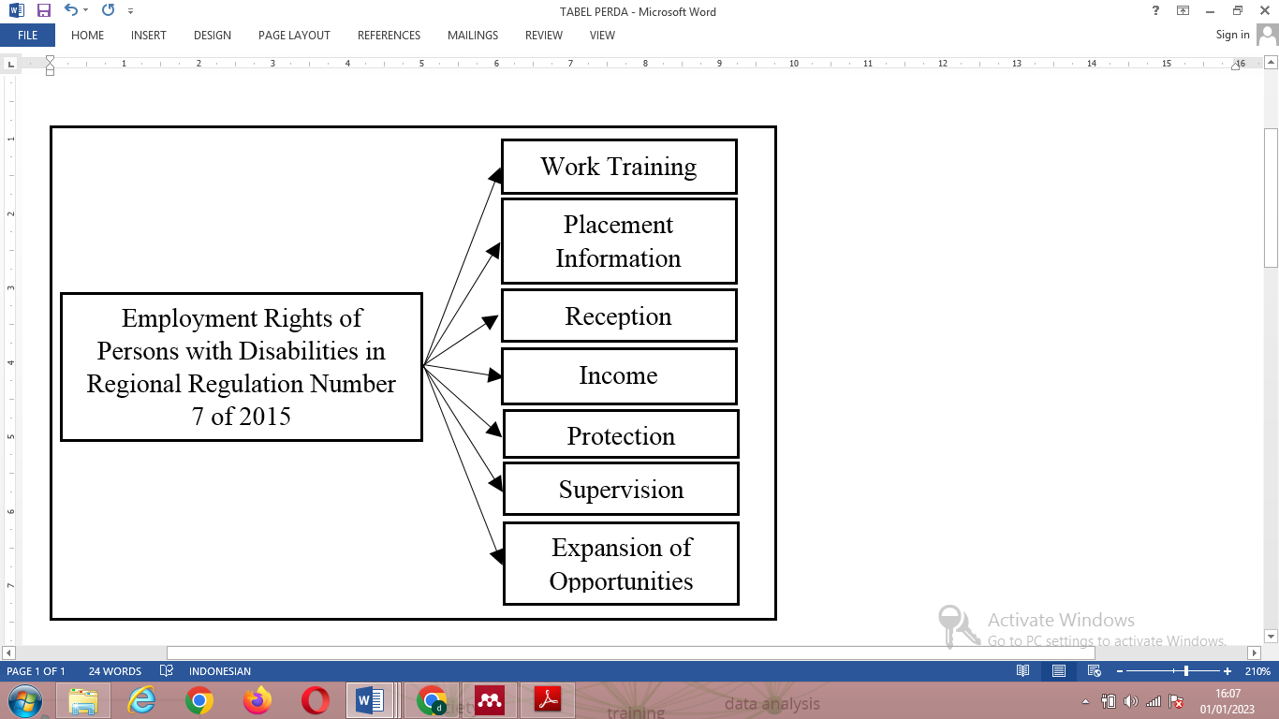
- Work Training, in this case for civil servants, is carried out in accordance with Government Regulation Number 101 of 2000 concerning Education and Training for Civil Servants and non-PNS positions, carried out through joining non-disabled training participants at the Job Training Centers of the Industry and Labor Agency, or by sending to the Office of the Ministry of Social Affairs or the Provincial Government of Central Java. However, in this case there is no specific job training for persons with disabilities due to a lack of training budget.
Source: Temanggung Regency Regional Regulation Number 7 of 2015
Figure 3. Types of Employment Rights of Persons with Disabilities
- Information on Manpower Placement, is the dissemination of information on job vacancies to persons with disabilities using electronic media such as websites, Instagram, Facebook, Telegram, Twitter, and through organizations of persons with disabilities in Temanggung Regency.
- Acceptance of Civil Servants and Labor, is divided into 2, namely Acceptance of Prospective Civil Servants and Labor. The acceptance of Prospective Civil Servants is carried out based on the needs of the Temanggung district government with the determination of the final formation from the central government, while the recruitment of workers is carried out by private companies with different policies for each company. However, in this acceptance, it is considered that they
- are still not pro-disability because they collide with requirements that make it difficult for persons with disabilities, especially the minimum educational requirements.
- Income, which is divided into 2, namely for civil servants and workers. For Civil Servants it is carried out based on Presidential Regulation Number 16 of 2019 concerning Adjustment of Basic Salary for Civil Servants According to Government Regulation Number 30 of 2015 into the Basic Salary of Civil Servants According to Government Regulation Number 15 of 2019 while for workers based on the Temanggung Regency Work Minimum Wage .
- Workforce Protection, provided in the form of health social security and employment social security according to the mandate of Law Number 24 of 2011 concerning Social Security Administering Bodies.
- Work Supervision, in 2016 this authority was withdrawn by the central and provincial governments. So that the Government of Temanggung Regency does not have supervisory authority. This has an impact on the slow decision-making process.
- Expansion of Job Opportunities, consisting of training, providing capital assistance, and mentoring. Provision of capital assistance in the form of a social safety net, which is a reserve fund so that it can be used at any time with a nominal amount of assistance according to the results of the assessment. However, the expansion of employment opportunities is hampered by the lack of companion human resources where there are only 3 people with a comparison of the total number of persons with disabilities in Temanggung Regency of 5,668 people.Policy formulation according to the character of the problem
Data on the total number of persons with disabilities reached 5,668 people, at the age of 18-40 years there were 1,437 people or 25.3% of the total number. In addition, out of a total of 27,769 workers, only 9 people are workers with disabilities or 0.03% of the total workforce in Temanggung Regency. This discrepancy in data shows that persons with disabilities experience difficulties in obtaining employment.
One of the causes of the high unemployment rate is due to the quality factor of human resources with disabilities. In addition, external factors in the form of work requirements that are applied are considered to be difficult for persons with disabilities, so that the role of the government is needed in overcoming this, one of which is through the issuance of the Regional Regulation which is formulated to contain matters needed in efforts to fulfill the rights of persons with disabilities. The formation of the Regional Regulation was started for the reason that when the program was going to be carried out, it was constrained by the absence of regulations governing the division of authority.
Policy Maker Conformity
Law Number 8 of 2016 concerning persons with disabilities revoking Law Number 4 of 1997 concerning Persons with Disabilities, in Article 27 paragraph (1) states that "The Government and Regional Governments are obliged to plan, implement and evaluate the implementation of Respect, Protection , and Fulfillment of the rights of Persons with Disabilities”. As for its formation, discussions were carried out on the Regional Regulation involving elements of the legislature with the approval of the executive, this is in accordance with the provisions of Article 1 of Law Number 12 of 2011 concerning the Formation of Legislation, namely that "Regency/City Regional Regulations are Legislations invitation formed by the Regency/Municipal Regional People's Legislative Council with the joint approval of the Regent/Mayor”.
Execution Accuracy
The implementation of the policy of fulfilling the employment rights of persons with disabilities is carried out by the Regional Government and the private sector. The Civil Servant Management policy for persons with disabilities is carried out by the staffing and human resource development agency. The staffing and human resource development agency is a regional apparatus that has the task of assisting the Regent in carrying out government affairs in the areas of staffing, education and training which are the authority of the region. The management of Civil Servants consists of Compilation and Determination of Requirements, Procurement, Rank and Position, Career Development, Career Patterns, Promotions, Transfers, Performance Appraisal, Payroll and Benefits, Awards, Discipline, Dismissal, Pension Benefits and Old Age Security, and Protection .
As for fulfilling the employment rights of persons with disabilities for Non Civil Servants it is carried out by the Government of Temanggung Regency in collaboration with APINDO. The initial step taken was to form a Disability Service Unit whose membership included 2 regional apparatuses that were leading sectors, namely the Industry and Labor Agency and the Social Agency, and involved APINDO (Indonesian Employers' Association). The Industry and Labor Agency is a regional apparatus that has the task of assisting the Regent in carrying out supporting functions for government affairs in the industrial and labor sectors which are the authority of the region and the co-administration tasks assigned to the regions. While the Social Agency is a regional apparatus that has the task of assisting the Regent in carrying out government affairs in the social sector which are the authority of the region and assistance tasks assigned to the region, In the Disability Service Unit, the Social Agency plays a role in providing data on persons with disabilities and their readiness for the job market which is then forwarded by the Industry and Labor Agency to manage and facilitate their labor rights. Meanwhile, APINDO, based on its Articles of Association, is a democratic, free, independent, responsible Indonesian employers' organization that specifically deals with the fields of industrial relations, employment, investment and business activities in the broadest sense in the context of realizing the implementation of industrial relations.
Target Accuracy
The target in implementing this policy is in accordance with what was planned, namely persons with disabilities in Temanggung Regency as stated in the consideration for the formation of the Regional Regulation namely that Persons with Disabilities are part of society who have the same position, rights, obligations and roles, so as to realize independence and prosperity Persons with Disabilities need recognition, respect for their dignity as human beings. Besides that, the phenomenon that occurs is that persons with disabilities are a group of people who experience difficulties in getting a job, and have not received much special attention from the Temanggung Regency Government so as to minimize the unemployment rate for persons with disabilities.
In implementing the fulfillment of labor rights in the Regional Regulation, there is a factor that is in the spotlight, namely the unpreparedness of inclusive education for persons with disabilities in Temanggung Regency. Even though the phenomenon that occurs is that the requirements for job applicants often include a minimum education so that the average person with disabilities in Temanggung Regency cannot fulfill it. So it can be said that persons with disabilities are not fully prepared for the intervention of this policy.
The intervention for implementing the policy to fulfill the employment rights of persons with disabilities based on the Regional Regulation is new. Echoes regarding fulfilling or protecting the rights of persons with disabilities as outlined in regional-level regulations in Temanggung Regency did not exist before 2015. Policies implemented at that time were only based on applicable provisions from the central and provincial government levels. Based on the anxieties of persons with disabilities who were inventoried, it finally led to the initiative to form local regulations that regulate the protection of the rights of persons with disabilities.
Environmental Accuracy
In this case there are 2 things, namely the internal environment and the external environment. In the internal environment (Internal Interaction), interaction is carried out based on the type of program, namely the Management of Civil Servants and the Implementation of the Disability Service Unit. Civil Service Management involves all regional apparatuses with the leading sector of the staffing and human resource development agency, with the following pattern:

Figure 5. Civil Servant Personnel Management Pattern

Based on this figure, the management of Civil Servants is carried out based on the service needs of each regional apparatus which is then managed by the staffing and human resource development agency whose impact is directly felt by Civil Servants.
As for the implementation of the Disability Service Unit involving the Social Agency and the Industry and Labor Agency with the following interaction pattern in figure 6 and 7.
The internal interaction of the Disability Services Unit is divided into two, namely: 1) Work Placement focuses on placing workers with disabilities in a company, so that a very prominent role lies with the Industry and Labor Agency in the form of providing information, facilitating registration, and facilitating industrial relations, while the Office of Social Affairs plays a role in providing data on persons with disabilities. 2) Expansion of Employment Opportunities focusing on independent business orientation for persons with disabilities, the Office of Social Affairs in this case has a more prominent role, namely providing data, providing capital assistance, and mentoring, while the Office of Industry and Manpower has a role in organizing training.
Meanwhile, the external environment of policy is in the form of public opinion. The policy was welcomed by those who were the object of the policy, although on the other hand there was disappointment because it had not met their expectations. Persons with disabilities still have not benefited from the existence of these regional regulations even though the contents are felt to be good and in accordance with their needs. There are many rejections of workers with disabilities from companies and the conditions that make it difficult for people with disabilities are still being applied to become a discourse that often arises. In addition, from the company's point of view, the company criticized the slow socialization process and had not even received the socialization of the regional regulations, so that many were still not aware of the existence of regional regulations and the provisions that should be implemented.
Figure 7. Internal Interaction Expansion of Job Opportunities
Figure 6. Internal Interaction of Work Placement
Factors Influencing Policy Implementation
Edward III (1980) suggested that there are 4 (four) factors that influence policy implementation, namely Communication, Resources, Disposition, and Bureaucratic Structure. In connection with the implementation of fulfilling the employment rights of persons with disabilities in Regional Regulation Number 7 of 2015, the researcher conducted an analysis of the influencing factors as follow in figure
Based on the figure, the Resource indicator is the most influential factor in the implementation of the Regional Regulation with a value of 47%, then Communication 23%, B ureaucratic Structure 20% and the smallest is Disposition 8%, with the following description:
Figure 8 Factors influencing Policy Implementation of Fulfillment of Employment Rights of Persons with Disabilities in temanngung Regency
Communication
Communication is one of the factors that influence policy implementation. The dimensions of communication according to Edward III (1980) in Tuti (2020) are divided into 3 (three) dimensions namely Transmission, Clarity and Consistency. The following is the result of an analysis of the implementation of communication in the implementation of the policy.
Based on the figure, the Clarity Dimension is the most influential dimension with a percentage of 35%, then the Consistency Dimension 33%, and finally the Transmission Dimension 31%, with the following description:
- The transmission dimension, in its implementation, the Regional Regulation is considered slow in its socialization so that many do

not know about the existence of the Regional Regulation, even though this is very much needed by the policy targets. For a long time, the Government of Temanggung Regency has not used it optimally in communicating the Regional Regulation so that it is delayed in fulfilling its rights.
- The clarity dimension, In this case, policy implementers can directly understand the contents of the policy because the policy content is in accordance with the duties and functions attached to the position. Executors already know what should be done about who does what.
- The consistency dimension, in this case policy communication has been implemented consistently. This is indicated by

the continued validity of the provisions in the Regional Regulations even though their implementation has not been

maximized and there have been no changes to the Regional Regulations.
Resources
Resources are divided into Human Resources, Budgetary Resources, Equipment Resources, and Authority Resources, with the following analysis results in figure 10. Based on the figure, it can be seen that Authority Resources are the most influential, namely 40%, then Equipment Resources 26%, Budget Resources 18%, and Human Resources 14%, with the following description:
Human Resources
In the implementation of this Regional Regulation, the role of Human Resources in the Personnel and Human Resources Development Agency, the Social Service, and the Industry and Manpower Office is very important both in terms of quality and quantity. The following is the condition of the position maps of the three regional apparatuses.

The three images are employee conditions obtained from position mapping based on the results of job analysis and workload analysis. In this figure, the condition of employees in terms of quantity is still far below the needs of the position so that there is a relatively high difference, while in terms of quality some of them have fulfilled but need to be improved. Conditions like this affect the implementation of these policies, considering that Human Resources are the main actors implementing the policy.
Budget Resources
A budget is a tool that assists in the process of planning and coordinating future activities to achieve goals (Giusti et al., 2018). In this case, there are different budgetary conditions at the Industry and Labor Agency and the Social Agency. In the Industry and Labor Agency there is no special budget allocation for persons with disabilities, while in the Social Agency there is always. The lack of budgetary resources in implementing the policy is one of the factors hindering activities at the Industry and Labor Agency. So that under these conditions, services at the Industry and Labor Agency are not optimal and policy implementation is affected.
Equipment Resources
Equipment Resources is one of the factors supporting the implementation of tasks both in terms of facilities and infrastructure, which is a basic thing that must be met by policy implementers. In this case the equipment resources at the Staffing and Human Resources Development Agency and the Social Agency are considered sufficient, but there are deficiencies in the Industry and Labor Agency in the form of a physical building for the Disability Service Unit. Apart from that, from a regulatory point of view, it is still lacking because there are no derivative regulations from the Regional Regulation so that the technical implementation has not been able to run properly because there is no legal basis to cover it.
Authority Resources
The Legal Product is the initial basis for carrying out the duties and authorities of the Temanggung Regency Government. In addition to regional regulations, arrangements are also made by establishing district regulations as follows:
- Temanggung Regent Regulation Number 19 of 2022 concerning the Duties and Functions of the Social Agency of Temanggung Regency, namely carrying out the preparation of policy formulation, coordination and implementation of policies, evaluation and reporting in the social rehabilitation of persons with disabilities.
- Temanggung Regent Regulation Number 30 of 2022 concerning Duties and Functions of the Industry and Labor Agency of Temanggung Regency, namely carrying out the preparation of policy formulation, coordination and implementation of policies, evaluation and reporting in the fields of placement, training, and productivity as well as expanding employment opportunities.
- Temanggung Regent Regulation Number 33 of 2022 concerning Duties and Functions of the Staffing and Human Resources Development Agency of Temanggung Regency, namely carrying out the preparation and determination of policies, implementation, monitoring, evaluation and reporting, as well as technical guidance in carrying out tasks supporting supporting functions in the field of staffing, education and training.
In addition, strategic decision-making from stake holders, namely heads of related agencies or agencies, in exercising their authority is important. The role of stakeholders is often carried out in order to accelerate the resolution of problems in employment services for persons with disabilities.
Disposition
Tuti (2020) says that one of the factors that influence the effectiveness of policy implementation is the attitude of the implementer. However, the success of implementation is also influenced by the support from superiors. The following is the result of dispositional analysis in the implementation of the Regional Regulation:

In the figure it can be seen that the implementer's response has the greatest influence, namely 42%, then the implementer's awareness is 36% and the lowest is superior support, 21%, with the following description:
Executor Awareness
In this case the executor is an employee who has a position lower than superiors or policy makers where each person gets the division of the main tasks and functions of each in order to achieve targets in the work unit or organization that oversees it. Executors' awareness can have a positive impact on their performance in optimizing policies. As for the reality on the ground in the implementation of the Regional Regulation, the executors have carried out their duties with their own awareness, which is a form of empathy for work so that it can facilitate the implementation of policies. But even this requires intensity and support from visionary superiors.
Implementer Response
Implementers' responses to policies can be either positive or negative. In this case, implementers in each relevant regional apparatus are able to respond positively or well to policies implemented with long-term intensity. The implementation of the activity program is formulated based on planning with predetermined targets so that it must be completed properly. But besides that, empathy has a positive impact so that policy implementation can run well when viewed from this perspective.
Leader Support
Support from leader to implementers, both morally and materially, is something that is very much needed in an organization, both in the public and private sectors. The superiors of the implementers of the Regional Regulations have tried to create a conducive work atmosphere and are able to motivate implementers, even though this is an external supporting factor but able to contribute to the implementation of the implemented program. Sealin that, the pattern of giving rewards to employees is also applied to regional apparatus so as to provide more motivation for employees to be able to further improve their performance. Muchinsky in (Hardianto, 2018) says that "Appreciation is something of value given to the employee on the basis of the elicited behavioral response; it is meant to reinforce the occurrence of the desired response. Most attention has been paid to the response reward connection.” Furthermore, the existence of awards can increase the motivation and morale of employees so that they can improve their performance.
Bureaucratic Structure
The bureaucratic structure or what is referred to as the organizational structure which contains a hierarchical chain is a system that is implemented in carrying out each program to achieve the set targets. Winarno (2014) in Ramadani (2019) suggests that there are two main characteristics of bureaucracy, namely work procedures, basic measures or often called SOPs and fragmentation. The following is the result of an analysis of the bureaucratic structure in the implementation of the Regional Regulation:
Based on the figure, SOP has a greater influence, namely 65% while Fragmentation is 35%, with the following description:
Standard Operating Procedures (SOP)
SOP is a series of procedures that are implemented in order to achieve a predetermined goal. In relation to the implementation of these Regional Regulations, there are several series of activities or systems implemented by each regional apparatus in seeking to fulfill the employment rights of persons with disabilities.
There are several service systems implemented by regional apparatus, namely the Integrated Referral Service System at the Social Agency which can be accessed by persons with disabilities to obtain various information or complaint services related to their problems, as well as the Smartbility program, namely “Siap Makaryo Untuk Disabilitas” whose purpose is to place and or expand opportunities work of persons with disabilities. Smartbility is a program that was initiated in order to support the work rights of persons with disabilities which consists of facilitating employment in creating an inclusive work environment through the Disability Service Unit.
Fragmentation
For the sake of work effectiveness and efficiency in each regional apparatus organization in the success of the policy, it is necessary to divide tasks and functions for each work unit. This is intended so that each item of activity can be carried out and managed in detail and in accordance with the objectives to be achieved. In the 3 regional apparatus implementing the Regional Regulation there is an organizational structure which is divided into several work units as follows:

- The Staffing and Human Resources Development Agency:

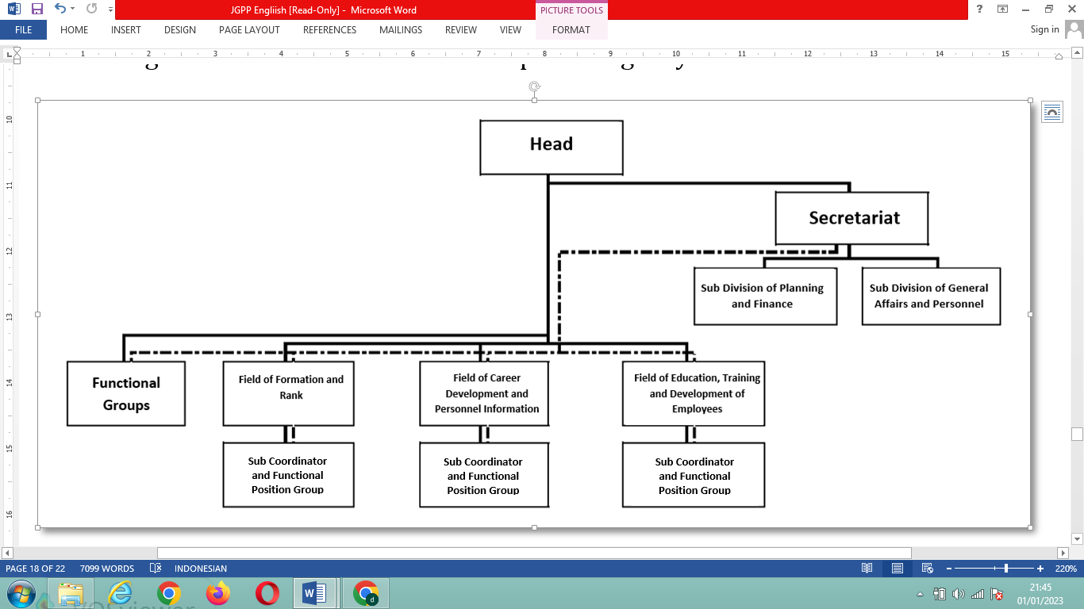
Source: Temanggung Regency Regent Regulation Number 110 of 2021
In carrying out the duties and functions of the Staffing and Human Resources Development Agency in civil service personnel management, the Head of the Agency is assisted by several work units namely the Secretariat, 3 work areas, and functional group positions.
- The Industry and Labor Agency:

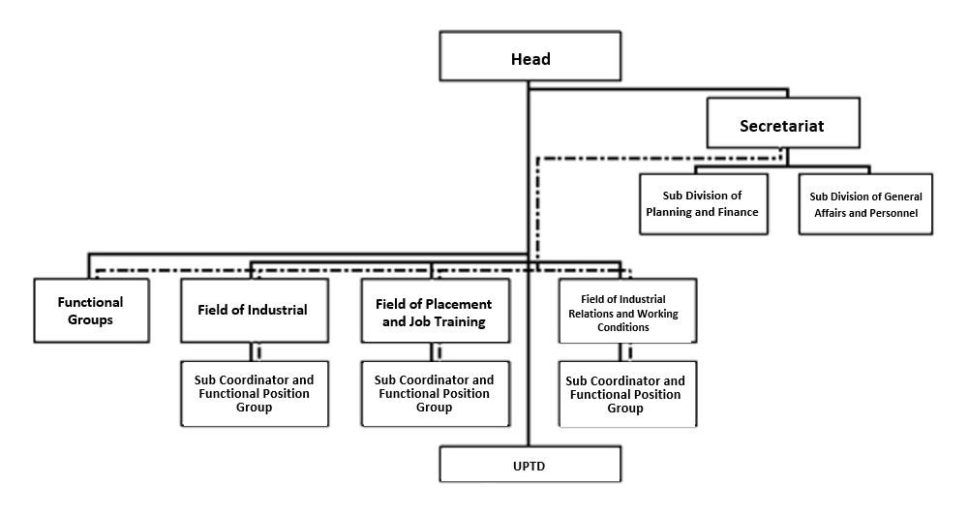
Figure 17. Organizational Structure of the Industry and Labor Agency
Source: Temanggung Regency Regent Regulation Number 110 of 2021
In carrying out the duties and functions of the service in fulfilling labor rights, the head of the service is assisted by several work units namely the secretariat, 3 fields, UPTD, and functional group positions.
- The Social Agency:
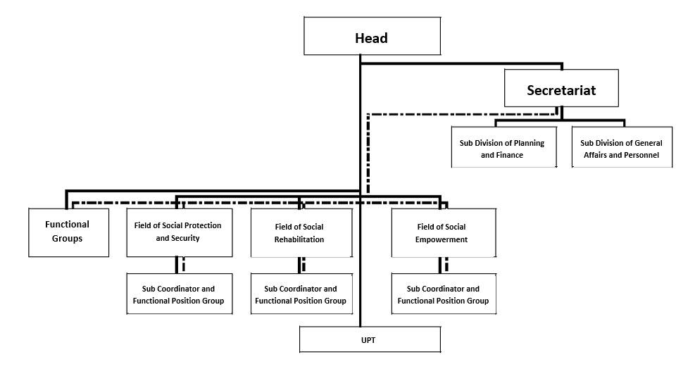
Figure 18. Organizational Structure of the Social Agency
Source: Temanggung Regency Regent Regulation Number 110 of 2021
The Social Agency in carrying out the tasks and functions of social services, the head of the service is assisted by a secretariat, 3 fields, UPT, and functional group positions.
The figures above show that in each regional apparatus the division of main tasks and functions and authority is applied to manage each task area based on their respective competencies and responsibilities. With the existence of a hierarchical line of authority, the head of the service has the right to distribute each of his powers to the work units below him so that each item of activity can run well according to the targets set.

CONCLUSION
The implementation of the policy of fulfilling the employment rights of persons with disabilities through the Regional Regulation of Temanggung Regency Number 7 of 2015 concerning Protection of the Rights of Persons with Disabilities has not been fully implemented properly, because there are still several problems, namely the recruitment of workers who are still not pro-disabilities because they collide with requirements that make it difficult for persons with disabilities disabilities, job training that does not yet have specificity for persons with disabilities and is still rarely implemented, the withdrawal of supervisory authority to the central and provincial governments thereby hampering decision-making at the Temanggung Regency Government level, lack of human resources assistants so that the implementation of assistance is not optimal in expanding employment opportunities, persons with disabilities not ready to be intervened by this policy due to the lack of preparedness of inclusive schools in Temanggung Regency, especially in terms of human resources, and the emergence of public opinion which shows that a dissatisfaction because of the slow and even no socialization of the policy to persons with disabilities and companies.
Factors that influence the implementation of these policies include the implementation of Regional Regulation communication on the dimensions of clarity and consistency dimensions that have been carried out well to the implementers of the Regional Regulations so that the implementers of the Regional Regulations are able to understand and implement policies according to their duties and functions, but are still weak on the transmission dimension, namely the socialization of Regional Regulations it is still very minimally implemented so that persons with disabilities and companies do not even know about the existence of regional regulations, in terms of resources: the quantity of human resources is still lacking, budget resources are very minimal or even non-existent at the Department of Industry and Labor, and equipment resources to support disability service units are still lacking, but this is minimized by having appropriate authority resources, policy implementers have awareness and a positive response to existing policies, and support from superiors has a positive impact in the implementation of policies, and the existence of SOPs which have a more positive influence on the bureaucratic structure, because this is a real form of service operation flow, but besides that the existence of fragmentation has a positive influence because there is a division of tasks and functions in each work unit according to the competency of the executor.
The author submits several suggestions to the Government of Temanggung Regency to monitor and evaluate the implementation of the policy so that weaknesses are identified that must be corrected, optimize the implementation of dissemination of Regional Regulations both to persons with disabilities and to companies so that all parties are aware of their existence and are willing to comply with every provision in the these policies, carry out proper planning both in terms of budget and staffing so that the resources that support the implementation of these Regional Regulations can be fulfilled, and are more active in coordinating both internally the Regency Government and externally both to the Central and Provincial Governments in order to receive positive support so that the implementation Regional Regulations can be implemented according to the expected target.
ACKNOWLEDGEMENT
We would like to thank the Master of Government Science at the Muhammadiyah University of Yogyakarta who always supports researchers and Suranto as a collaborative research partner in the success of this research

References use a referral technique with the APA system (name, year). The inclusion of the source’s indirect references should be accompanied by information about the page number where the citation came from. Example: (Held, 2004). High recommended the author(s) use reference management such as Mendeley, Zotero, etc.
If there are tables or figures to be adjusted to the size of the tables or figures. For the table to be made like the following example:

Table 1.
No | content 1 | content 2 | content 3 | ……
Sources:

Figure 1.


Sources:

References are libraries published in the last 10 years. Preferred references for research articles are primary sources in the form of journals (80%) and research reports (including thesis, thesis, and/or dissertation) or research articles in scientific journals and/or magazines.

CONCLUSION
Convey summarize the results and discussion of research or discussion.

REFERENCES
The reference list is arranged in the following manner and is arranged alphabetically and chronologically as follows:

Single Author
Held, David. (2004). Democracy and the Global Order: From the Modern State to Cosmopolitan Governance, Oxford: Marston Book Services Ltd.

Collaboration
Haferkamp, Hans & Neil J. Smelser. (1992). Social Change and Modernity, Berkeley: University of California Press.
Editors
Koentjaraningrat (ed). (1983). Metode-Metode Penelitian Masyarakat. Jakarta: Penerbit PT Gramedia.

Translation
Lauer, Robert H. (1993). Perspektif tentang Perubahan Sosial. Terjemahan Alimandan, Jakarta: PT Rineka Cipta.

Book Chapter
Fleishman, L.A. (1973). “Twenty Years of Consideration and Structure”. Dalam Fleishman, I.A. & J.G. Hunt (ed.), Current Development in the Study of Leadership: Selected Reading, pp. 1-37. Carbondale: Southern Illinois University Press.
Journal
Akbar, I. (2017). Khilafah Islamiyah: Antara Konsep dan Realitas Kenegaraan (Republik Islam Iran dan Kerajaan Islam Arab Saudi). Journal of Government and Civil Society, 1(1). pp. 15-30
Newspaper
Pitunov, B., 13 Desember 2002. Sekolah Unggulan Ataukah Sekolah Pengunggulan? Majapahit Pos, pp. 4 & 11.
Newspaper (without name):
Pikiran Rakyat. 26 November, 1988. Pemerintahan Adat Kampung Naga, pp. 5.
Official Document:
Pusat Pembinaan dan Pengembangan Bahasa. (1978). Pedoman Penulisan Laporan Penelitian. Jakarta: Depdikbud. Undang-undang Republik Indonesia Nomor 2 tentang Sistem Pendidikan Nasional. 1990. Jakarta: PT Armas Duta Jaya.
Thesis, Dissertation or Research Report:
Hanapiah, Pipin. (2012). Perubahan Politik Golongan Karya: Studi Interaksi Pengurus Partai Golkar Kota Bandung di Era Reformasi. Tesis tidak Diterbitkan, Bandung: Program Pascasarjana FISIP UNPAD.
Seminar Paper:
Waseco, M.G. (2001). Isi dan Format Jurnal Ilmiah. Makalah Disajikan dalam Seminar Lokakarya Penulisan Artikel dan Pengelolaan Jurnal Ilmiah, Universitas Lambungmangkurat, Banjarmasin, 9-11 Agustus.
Internet:
Boon, J. (tanpa tahun). Anthropology of Religion. Diakses 5 Oktober 2003. diakses dari http://www.indiana.edu/-wanthro/religion.htm
Internet (Discussion Subject):
Wilson, D. Diakses 22 November 1995 dari Sumary of Citing Internet Sites. Nettrain Discussion List, <NETTRAIN@ubvm.cc.buffalo.edu>

The references only include referenced sources

ACKNOWLEDGEMENT (if available)

